    ATRIA CONVERGENCE TECHNOLOGIES LIMITED. | Print

25/5/140,1st Floor, N R Peta, Third Wada, Eluru-534006 Ph.No : 0866-6681000
E-mail : helpdesk.vjw@actcorp.in

CIN : U72900KA2000PLC027290

GSTIN No : 37AACCA8907B1ZX

PAYMENT RECEIPT
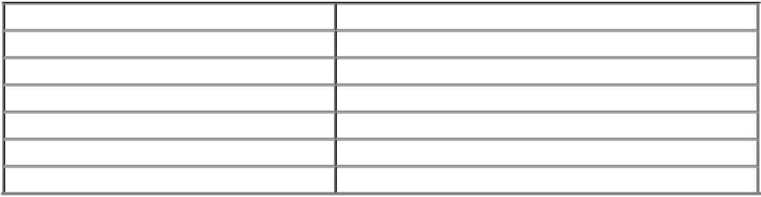

Received from | M. Thrinath Babu
Account Number | 105520087663
Payment Number | T1,18f0dfa,0
Date of payment | 04/02/2021
Transaction Reference number | 20210204111212800110168588980782370
Amount | Rs.4064/-
Transaction details | OP

Note: No signature required as this document is generated electronically.

